Lab 1:

**1. Generate SSH Key Pair**

ssh-keygen -t rsa -b 4096

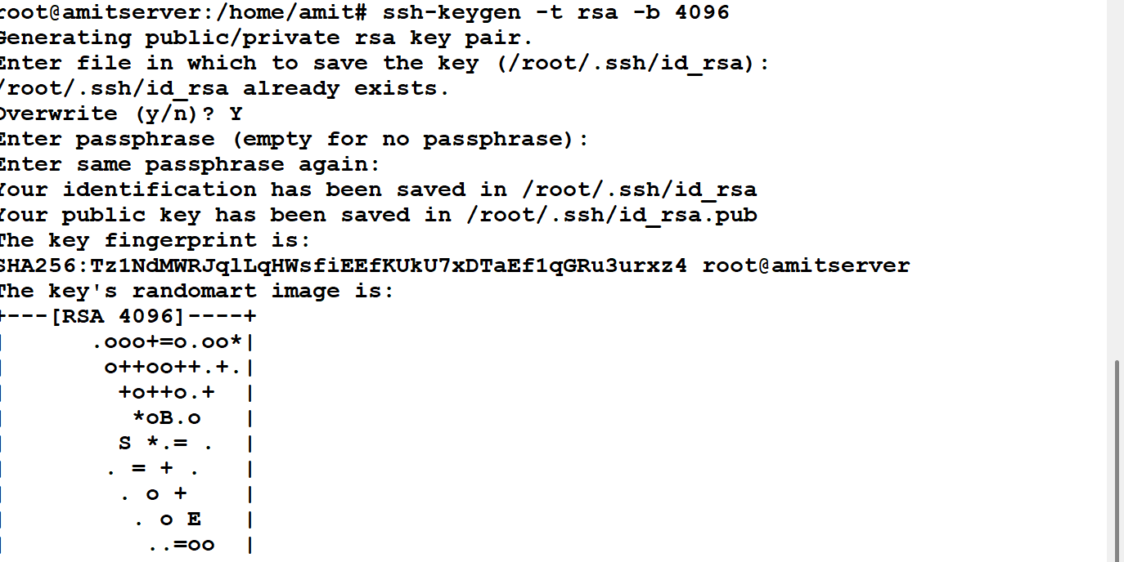

**2. Add the SSH Key to the SSH Agent**

Start the agent:

eval "$(ssh-agent -s)"

Add the private key:

ssh-add ~/.ssh/id_rsa

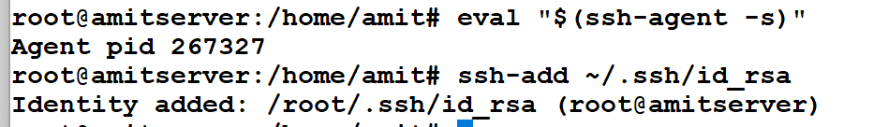

**3. Copy the Public SSH Key**

cat ~/.ssh/id_rsa.pub

* Copy the entire output that starts with ssh-rsa.

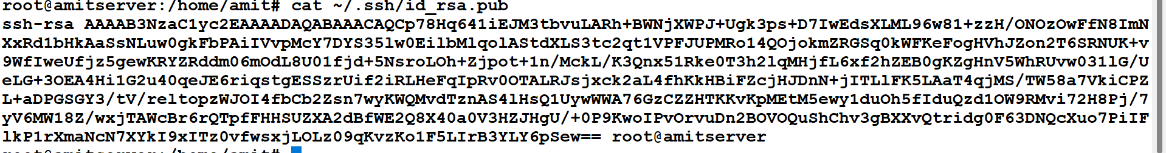

**4. Add SSH Key to GitLab**

1. Log in to GitLab.

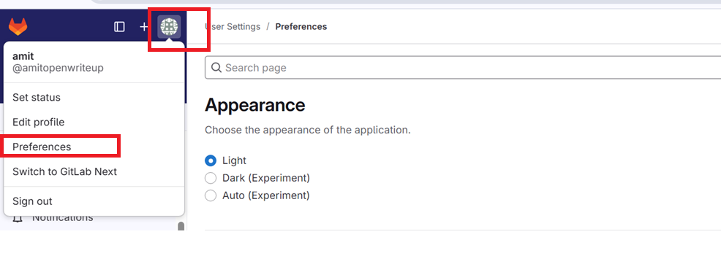

1. Go to **User Settings** > **SSH Keys**.
2. Paste your copied key into the **Key** field.
3. Click **Add key**.

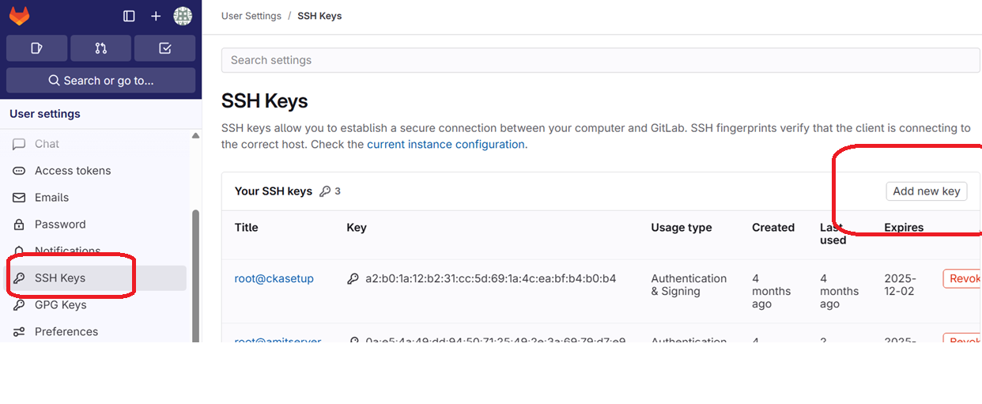

1. **Create project🡪blank project**



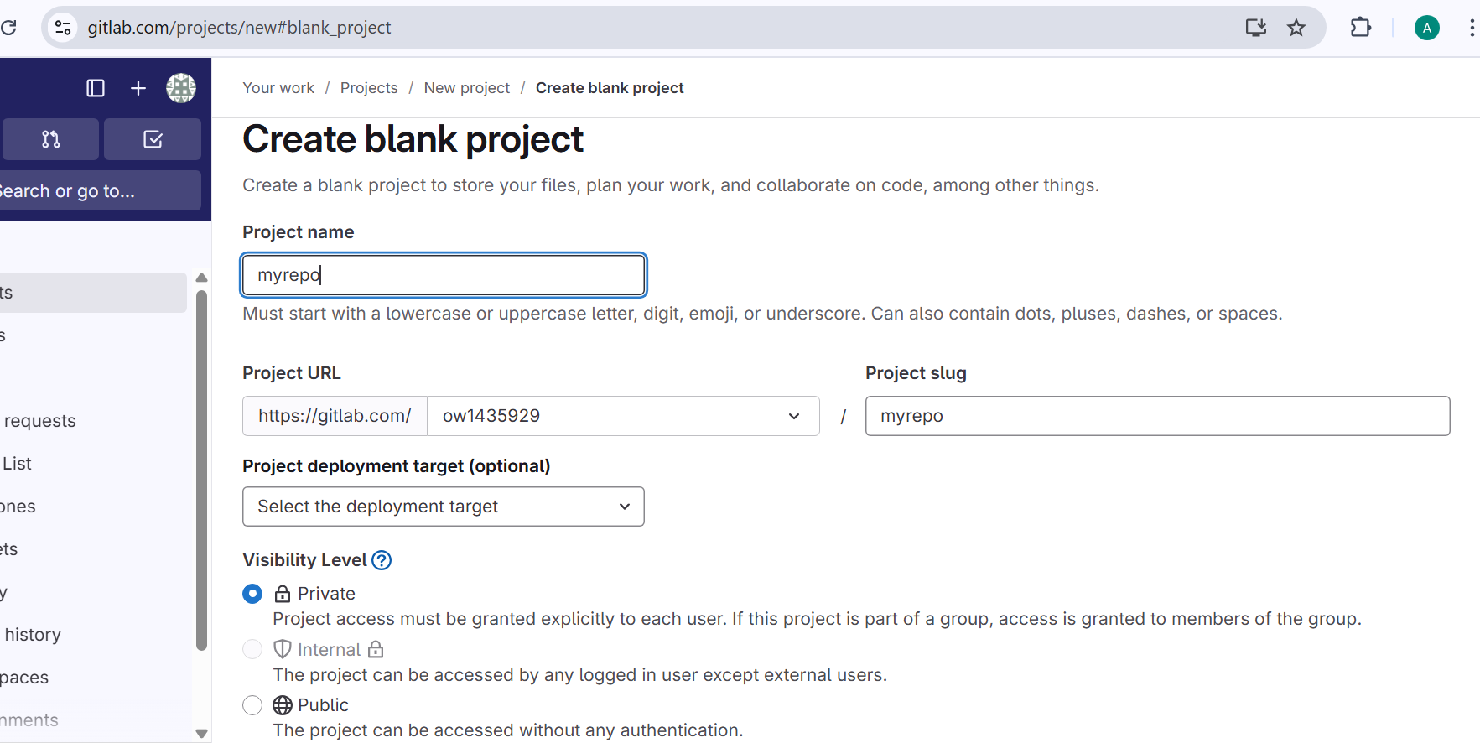

**6. Clone a GitLab Repository Using SSH**

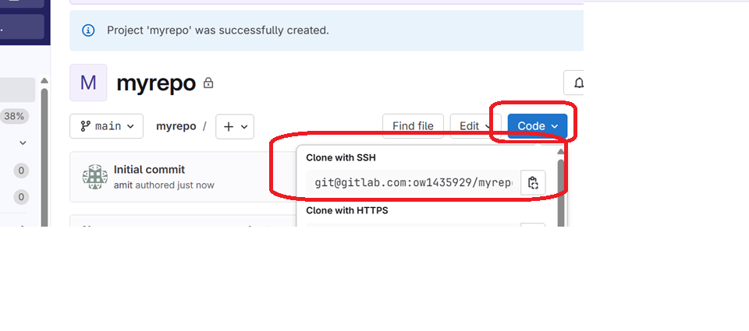

git clone git@gitlab.com:your-username/your-repo.git

